PRESS RELEASE

Martinez Historical Society
PO Box 14 (1005 Escobar Street)
Martinez, California

August 28, 2013
Contacts:

Carolyn Boone Duncan, Chair
Email: cfboone@aol.com
Telephone: (925) 864-8457

Janie Mori, Media Relations
Email: morijane@yahoo.com
Telephone: (925) 228-0158

John D. Curtis, President
Email: CurtisJD@ix.netcom.com
Telephone: (925) 957-1000

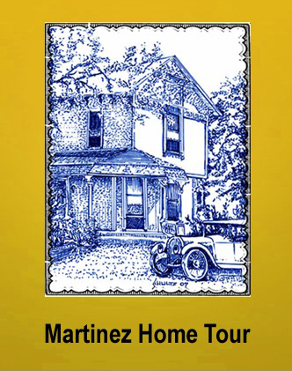

MARTINEZ – On Saturday, October 12th, experience the rich fabric of local history and residential architecture in Martinez by attending the 7th annual Historical Home Tour sponsored by the Martinez Historical Society. Take a tour of six or more private homes representing the historic home styles of the late 19th and early 20th centuries in Martinez.

Also included on the Tour are six public buildings. The tour begins at one of these structures: the Shell Clubhouse with its intact Craftsman Era interior and the adjacent Shell Oil Museum – both located at 1635 Pacheco Boulevard. The tour also includes the 1890 Borland House, a Carpenter Gothic structure which is the home of the Martinez Museum. It also includes John Muir’s 1882 Italianate Victorian mansion and the adjacent 1849 Martinez Adobe.

Also, on the tour this year is the First Congressional Church of Martinez with its symbolic stained glass windows. The Church was established in 1874, and the present building is a beautiful Spanish Revival structure which was built in 1928.

Tickets are $25 in advance and $30 at the door the day of the event. Tickets can be purchased with cash or check from Char’s Flowers (635 Main Street), Rumain’s Jewelry (510 Center Avenue), Bagel Street Café (580 Center Avenue), The UPS Store (the Lucky Shopping Center) and I’ve Been Framed (411 Ferry Street). For purchases via credit card, please go to Eventbrite (www.martinezhometour2013.eventbrite.com).

Proceeds from the Tour will benefit the Historical Society’s effort to restore and reopen the Old Train Depot in downtown Martinez. Portions of the Depot date back to 1877.

The Tour is self-paced. You can drive the Tour route, or utilize the free shuttle service that will be provided, with bus departures approximately every 10 minutes. Tour guides on the bus will entertain you with stories of Martinez and its history.

You may wish to walk the tour and enjoy the quaint neighborhoods where the homes are located. You will also be able to visit with the Docents and learn more about each home. Also enjoy various displays, demonstrations and music. You should allow at least two (2) hours to take the Tour.

The Tour will take place rain or shine. Tour hours are from 10 am to 4 pm. Wear comfortable shoes.

For more information, please visit the Tour website (www.MartinezHomeTour.com). While you are at the website, enjoy viewing photos of the homes which were on past tours.

No children under 12 years of age (infants may be carried in arms or belly carrier). Due to the period of the homes, they are not wheelchair accessible. We regret that taking pictures is not allowed inside the homes.

A special thanks to the Tour’s sponsors who make the Tour possible. These are the gold sponsors:

- Shell Martinez Refinery
- S and S Supplies & Solutions
- Cole Real Estate

And these are the Tour’s bronze sponsors:

- Allied Waste
- Shell Chemical
- Shell Western States Federal Credit Union
- Hagin’s Automotive
- Remodel Me
- Wendt Heating and Air
- Dolan’s Lumber, Doors and Windows
- Bay Alarm
- State Farm Insurance (Mark Woodard, Agent)

See photos below. Contact Janie Mori at morijane@yahoo.com for additional information or photos. You can also visit the website: www.MartinezHomeTour.com
